Modern Vidya Niketan


Project Report
Music Playlists and Songs Organiser

By: Arnav Gupta
Roll no. :
Subject: Computer Science

Acknoledgement
I would like to express my special thanks of gratitude to my teacher Mrs. Mandeep Walia, who gave me the golden opportunity to do this wonderful project of Computer Science on “Music Playlists and Songs Organiser” who also helped me in completing our project. I came to know about so many new things and am really thankful to them. Secondly, I would also like to thank my friends who helped me a lot in finalizing this project within the limited time frame.

Certificate
This Is to Certify that Arnav Gupta
CBSE Roll No.:
Has successfully completed the Project Work Entitled “Music Playlists and Songs Organiser” in the subject Computer Science laid down in the regulations of CBSE for the purpose of Practical Examination in Class XII to be held in Modern Vidya Niketan on ___________.

(Mandeep Walia)
PGT Computer Science

Examiner:
Name:
Signature:
Date:

Synopsis

Introduction:
“Music Playlist and songs organiser” is an application designed to allow different users to find their favorite songs and organise them into playlists of their choice. Users can either search songs as they wish or let the program choose some for them depending upon their mood. This application combines full user authentication, data storage, retrieval and recommendations, packing them into a beautiful User interface to give the users the best experience possible.

Objectives:
The objective of this project is to let the students apply the programming knowledge into a real-world situation.
This project involves:
- Writing programs utilizing modern software tools.
- Appling object-oriented programming principles effectively when developing small to medium sized projects.
- Writing effective procedural code to solve small to medium sized problems.
- Students will demonstrate a breadth of knowledge in computer science, as exemplified in the areas of systems, theory and software development.
- Students will demonstrate ability to conduct their own research, hence allowing writing and presentation skills to exemplify scholarly style in computer science.
Features
This project uses the streamlit module to lay out a beautiful and interactive user interface. It uses the MYSQL connector for backend connectivity to store data and the spotipy module to search and retrieve song data.
- Login and signup by user
- Search songs via query
- Song recommendations via mood
- Create new playlist
- Add songs to playlist
- Delete songs from playlist
Technology Used:
- Frontend: Python
Python is a high-level, interpreted programming language that’s easy to work with and very flexible. It uses dynamic typing and comes with powerful built-in data structures, which makes it a great choice for quickly building applications. Because of this, Python is often used not only to create full programs but also as a scripting or “glue” language to connect different software components.
One of Python’s biggest strengths is its clean and readable syntax. It’s easy to learn, and its clarity makes programs simpler to understand and maintain over time. Python also supports modules and packages, which helps developers organize their code and reuse it across projects. The language and its large standard library are free, open-source, and available on all major platforms.
Many programmers grow to love Python because it boosts productivity. Finding and fixing bugs is usually straightforward—errors don’t crash the program in unpredictable ways. Instead, Python clearly reports problems by raising exceptions. It also includes a powerful debugger that lets developers step through code, inspect variables, and test expressions. And sometimes, debugging is as simple as adding a few print statements, thanks to Python’s quick and efficient edit-test-debug workflow.

- Backend: MYSQL
MySQL is a relational database management system (RDBMS) that works on almost all major platforms, including Linux, Unix, and Windows. It is especially popular for web-based applications and online publishing. MySQL is a core part of the open-source LAMP stack, which includes Linux, Apache, MySQL, and PHP.
MySQL is free and open-source and uses Structured Query Language (SQL) to manage data. It is known for being fast, reliable, and scalable, making it a strong alternative to many commercial database systems. MySQL provides a wide range of features that help create a secure environment for storing, managing, and accessing data efficiently.
SQL offers different types of commands, each designed for specific tasks. These commands are grouped into the following categories:
  - Data Definition Language (DDL)
  - Data Manipulation Language (DML)
  - Transaction Control Language (TCL)
  - Session Control Commands
  - System Control Commands
Why choose MySQL over other databases?
MySQL is often preferred because it is easy to use, reliable, and well-suited for web applications. It offers good performance, handles large amounts of data efficiently, and is open-source, which helps reduce costs. Strong community support and compatibility with many programming languages also make MySQL a popular choice.
File Hierarchy:
The Entire Source Code of the application has been cleanly structured into variety of files and the concept of custom modules has been used to integrate said files.
Project/
│
├── proj_frontend.py
├── proj_backend.py
│
└── pages/
├── account.py
├── components.py
├── home.py
├── mood_songs.py
└── playlists.py

Source Code

Output

Login Dialog box
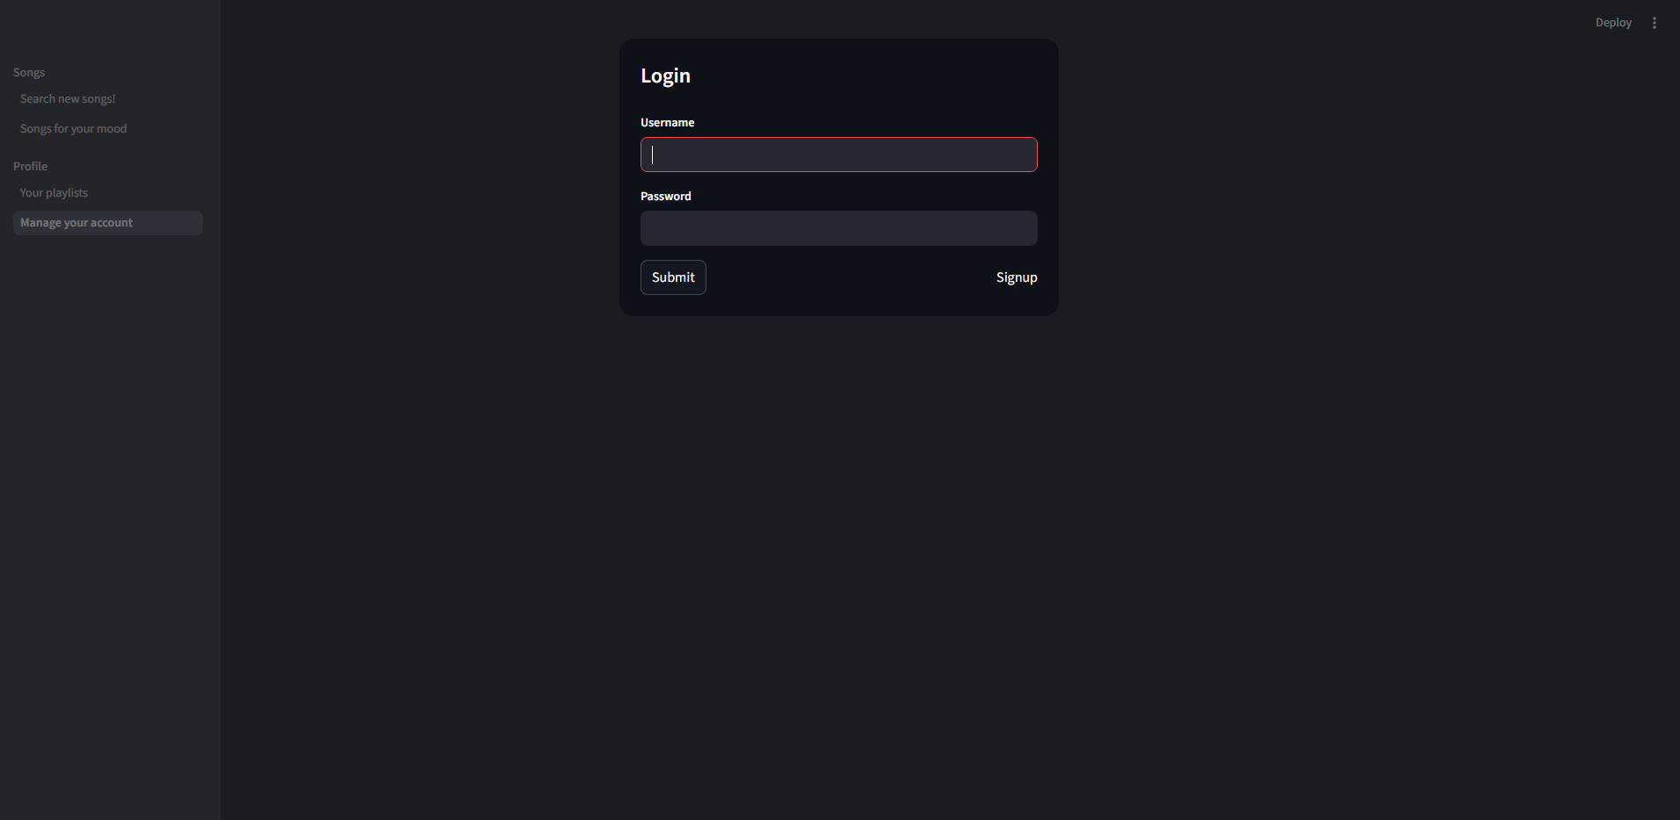

After Successful Login
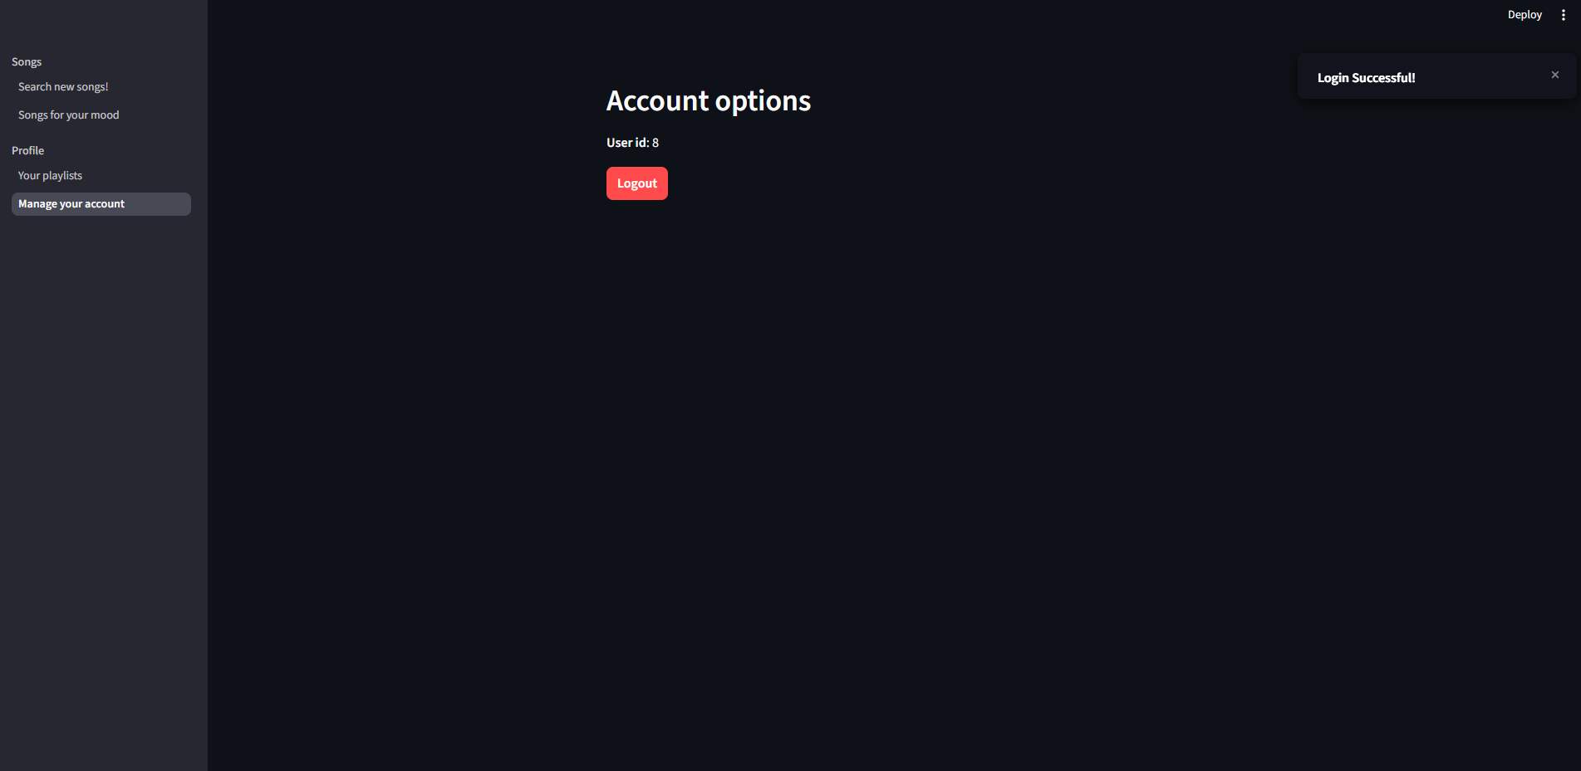

Searching Songs via queries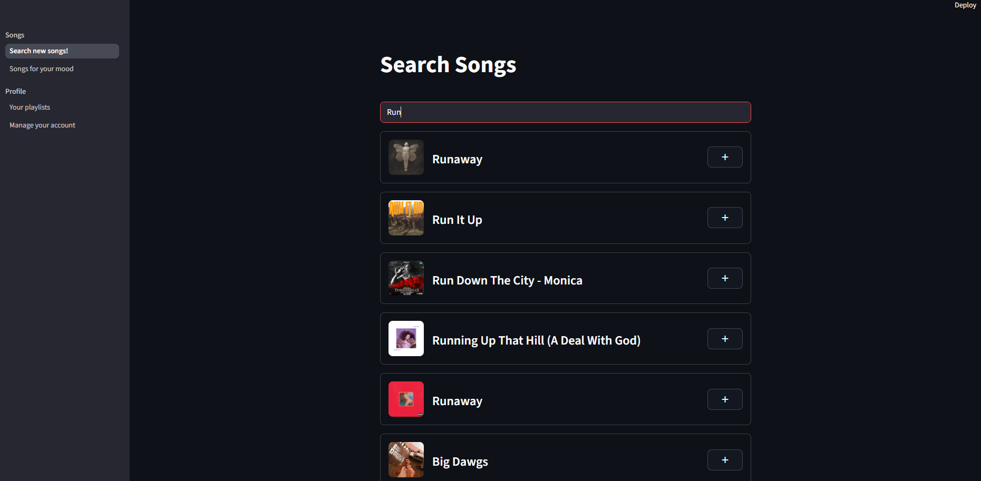

Selecting your mood for tailored songs
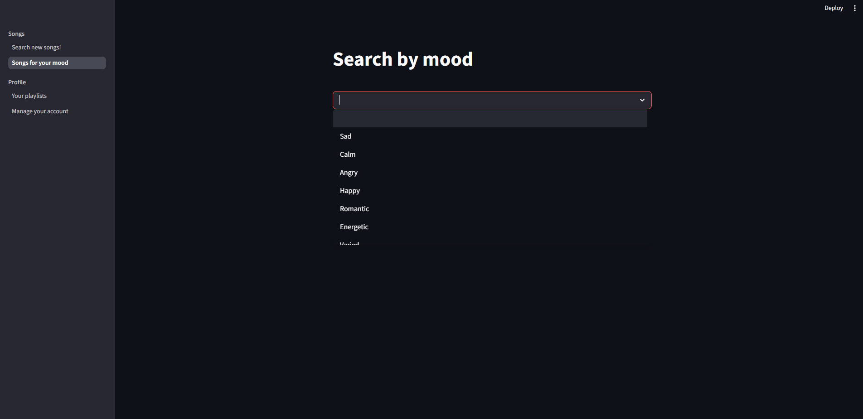

Obtaining tailored songs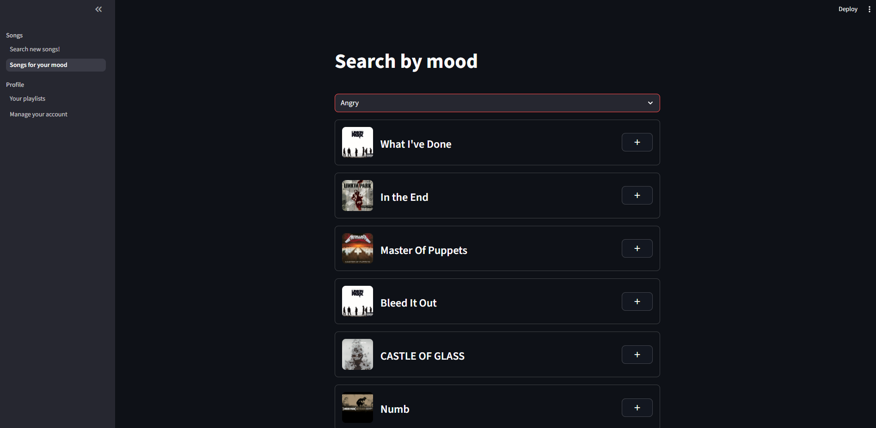

Adding Songs to Playlists
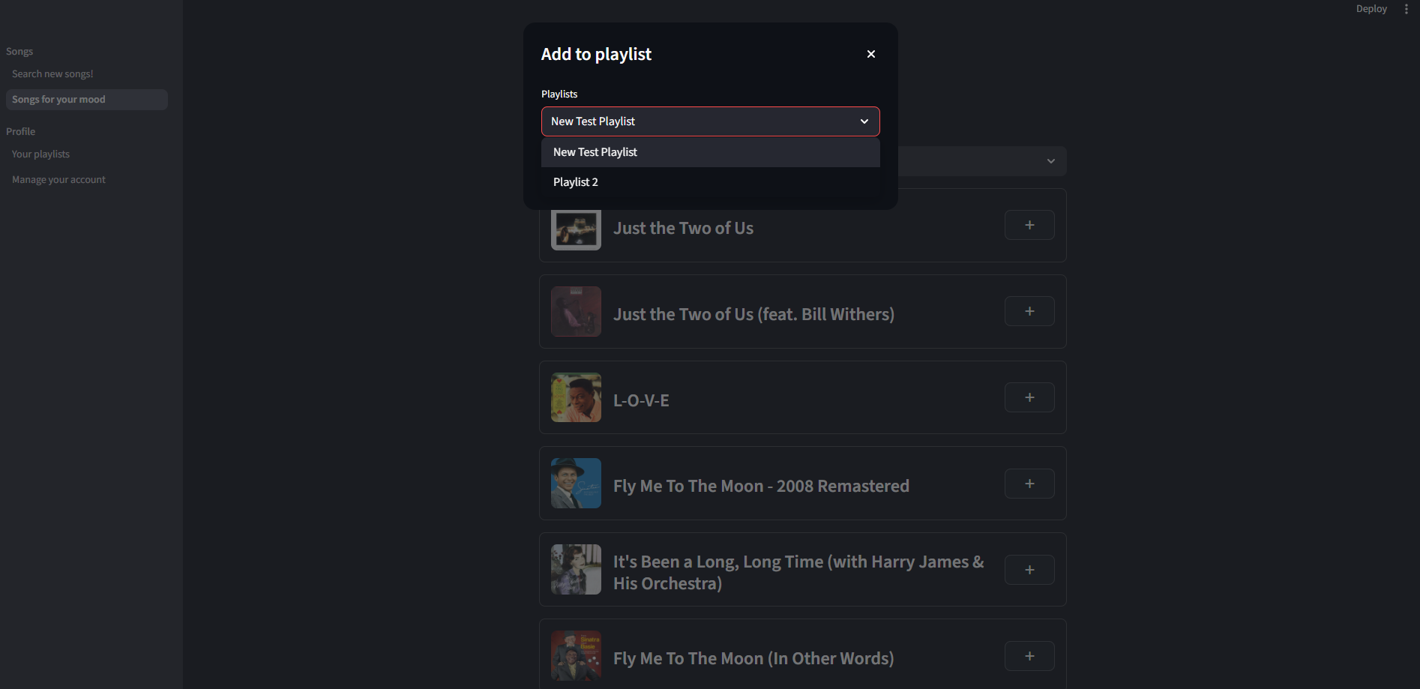
Your Playlist Page

Creating New Playlist
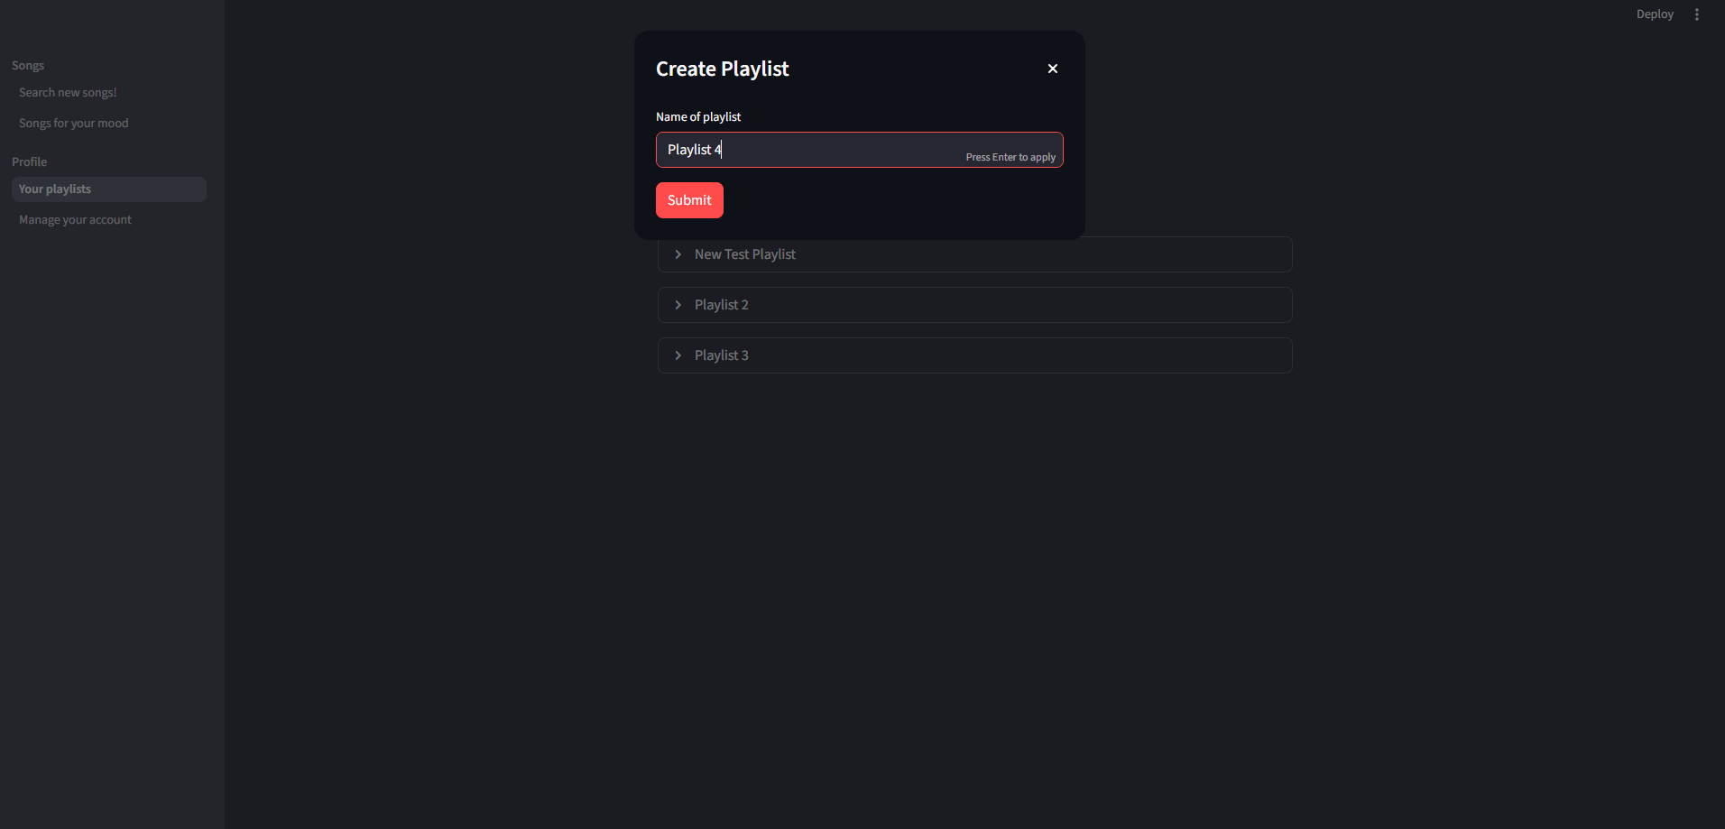
Expanding Playlists to see songs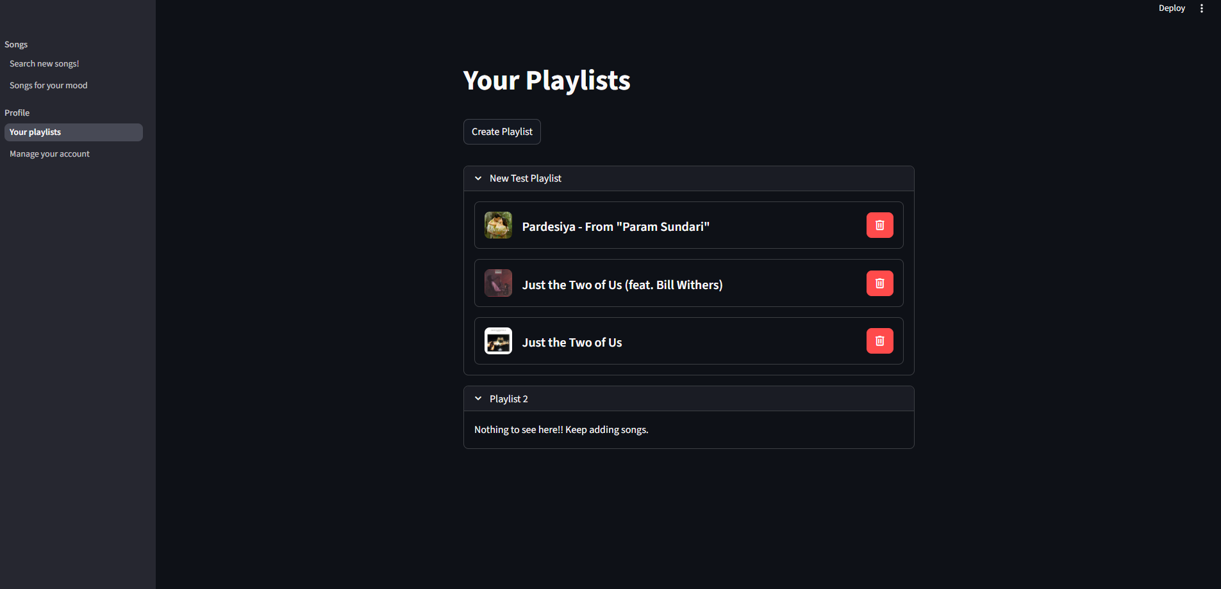

Bibliography
- Computer Science with Python-Class XII By: Sumita Arora
- https://www.google.com
- https://www.python.org.in
- https://www.mysql.org
- https://docs.streamlit.io
- https://developer.spotify.com/documentation/web-api
- https://github.com/real-cognitive/Record-File-Python/tree/main/Project (Entire project in github)

